WHAT IS DATA ENGINEERING?
Concept
- Raw data is valuable but not usable in its native state.
- Data is messy, voluminous, and needs to be processed to become a valuable product.
- Data Engineers build the structure that makes this possible.
- Without this infrastructure, data science and analytics cannot happen at scale.

DATA LIFECYCLE
Data Lifecycle – Overview
- Data follows a predictable path from its creation to its final use.
- This path provides a crucial framework for all data engineering work.
GENERATION
- Data are a collection of discrete or continuous values that convey information, describing the quantity, quality, fact, statistics, other basic units of meaning, or simply sequences of symbols that may be further interpreted formally.
RETRIEVAL
Gathering data can be accomplished through:
- Primary source: the researcher is the first person to obtain the data.
- Secondary source: the researcher obtains data that has already been collected by
other sources, such as data disseminated in a scientific journal.
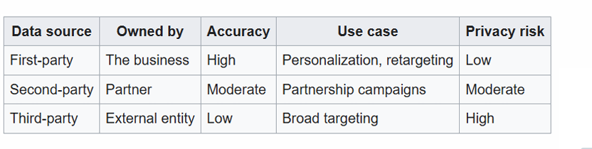

INGESTION
The process of moving data from its source into a centralized storage system.
Batch Ingestion
- Higher latency (minutes to hours)
- More efficient for large volumes
- Easiest to implement and debug
- Lower infrastructure costs
Streaming Ingestion
- Low latency (seconds to milliseconds)
- More complex to implement
- Higher infrastructure costs
- Enables real-time analytics
Micro-Batch Ingestion
- Near real-time processing (typically 5–15 minutes)
- Balances latency and efficiency
- Easier than true streaming
- Good for most use cases
STORAGE
- Persistently storing the ingested data for future use.
- Structured or Unstructured
- Normalized or Denormalized
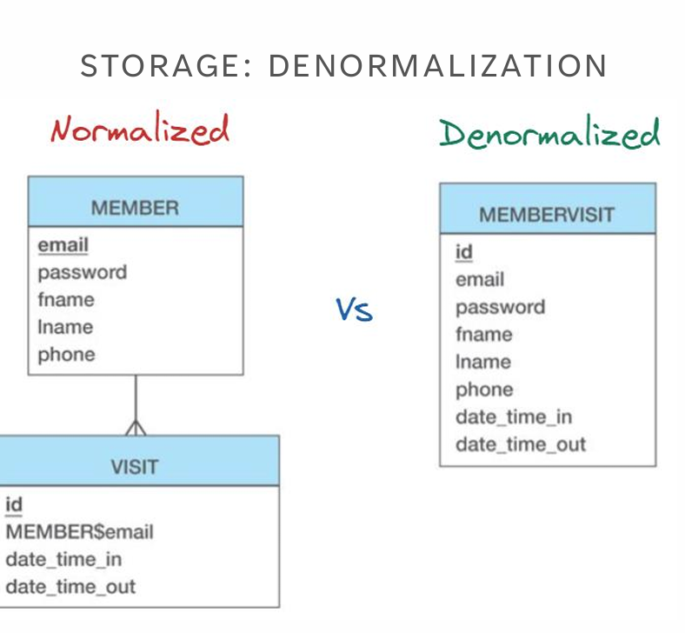

PROCESSING
Clean, Validate, Aggregate, Enrich, Transform
SERVING
Data Warehouse, Data Lakehouse, Data Mesh, API, Flat files by email?, Dashboards?
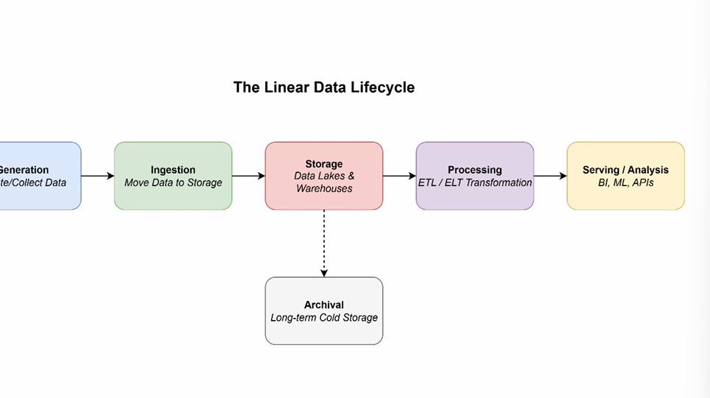

EL, ETL OR ELT
SUBJECT CURRICULUM
E – Extract
- Reading and pulling data from one or more source systems.
- Sources: Databases (SQL, NoSQL), APIs, SaaS applications (e.g., Salesforce), Log files
T – Transform
- The "business logic" step. Cleaning, enriching, and restructuring data.
Examples:
- Joining tables, Aggregating values, Masking PII, Converting date formats
L – Load
- Writing the processed data into a target destination.
- Targets:
  - Data Warehouse, Data Lake, Data Mart
EL (Extract–Load)
Examples:
- Database Replication: Creating a read-replica of a production database for analytical queries
to avoid impacting production performance.
- Data Lake Ingestion: Moving raw files (logs, images, JSON) into a data lake like S3 or ADLS
for long-term storage or future processing.
- Backup and Archiving: Simply moving data from one location to another for safekeeping.
Classic ETL
- Extract data from sources.
- Move it to a separate staging area or processing server.
- Transform the data (clean, join, aggregate). This is often a resource-intensive step.
- Load the clean, structured data into the target Data Warehouse.
ETL: PROS & CONS
Pros
- Mature & Well-Established: Tools are robust.
- Compliance-Friendly: PII can be scrubbed before loading.
- Performs Complex Logic: Optimized for heavy transformations.
- Reduces Load on Warehouse: Warehouse only handles queries.
Cons
- Slow & Rigid: Adding a new field can take weeks.
- Brittle: Transformations can break with source changes.
- High Maintenance: Requires specialized skills to manage.
- Not Ideal for Raw Data: Raw data is discarded after transformation.

(Modern) ELT
- Extract data from sources.
- Load the raw, untouched data directly into the target system (usually a cloud data warehouse
like Snowflake, BigQuery, or Redshift).
- Transform the data inside the warehouse using its powerful processing engine (e.g., using SQL).

ELT: PROS & CONS
Pros
- Speed & Flexibility: Load raw data in minutes, not hours.
- Leverages Cloud Power: Uses the scalable compute of the warehouse.
- "Schema-on-Read": No need to define structure upfront.
- All Data is Available: Analysts can access raw data for new insights.
Cons
- Potential for a "Data Swamp": Requires good governance.
- Cost Management is Key: Pay-per-query models can get expensive.
- PII is Loaded: Sensitive data enters the warehouse raw.
- Transformation logic is in SQL: Can become complex to manage.

ETL vs ELT: Comparison
Feature | ETL (Extract, Transform, Load) | ELT (Extract, Load, Transform)
Transform Location | Staging Server / ETL Tool | Target Data Warehouse
Data Structure | Schema-on-Write (Structure first) | Schema-on-Read (Flexibility first)
Load Speed | Slower (waits for transform) | Faster (loads raw data immediately)
Data Availability | Only transformed data is available | Raw + Transformed data are available
Infrastructure | On-premise or Cloud | Primarily Cloud-based
Ideal Use Case | Structured data, strict compliance, complex pre-defined reports | Big data, semi-structured sources, exploratory analysis, speed
Example Tools | Informatica, Talend, SSIS | Fivetran, dbt, Snowflake, BigQuery

DATA GOVERNANCE
WHAT IS DATA GOVERNANCE
- Formal management of data assets throughout their lifecycle
- Set of processes, policies, and standards ensuring data quality, security, and compliance
Key Objectives:
- Data Quality & Integrity
- Data Security & Privacy
- Regulatory Compliance
- Data Accessibility & Usability
WHY SHOULD WE CARE
Business Impact:
- Poor data costs organizations $15M annually (average)
- 40% of business initiatives fail due to data quality issues
Engineering Challenges:
- Data pipeline failures due to schema changes
- Inconsistent data formats across systems
- Security vulnerabilities in data flows
- Compliance violations (GDPR, CCPA)

DATA GOVERNANCE CORE PILLARS
- Data Quality Management
  - Accuracy, Completeness, Consistency, Timeliness
- Data Security & Privacy
  - Access controls, Encryption, PII protection
- Data Lifecycle Management
  - Creation, Storage, Usage, Archival, Deletion
- Metadata Management
  - Data lineage, Cataloging, Documentation

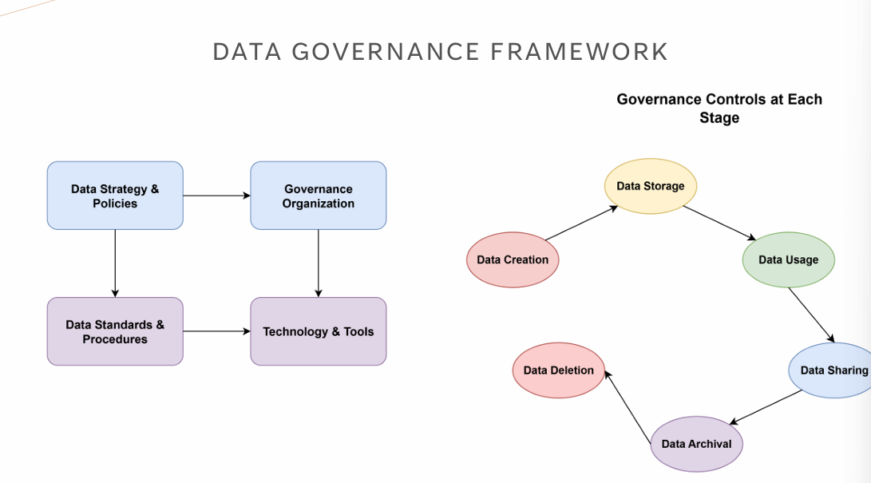

KEY ROLES
- Data Governance Council
  - Strategic oversight and policy decisions. Este está por encima de los otros,
- Data Owners
  - Business accountability for specific datasets
- Data Stewards
  - Day-to-day data management and quality
- Data Engineers
  - Implement governance controls in pipelines
  - Ensure data lineage tracking
  - Maintain data quality checks

GOVERNANCE TASKS FOR DATA ENGINEERING
- Pipeline Development:
  - Schema validation and evolution
  - Data quality checks at ingestion
  - Error handling and monitoring
- Infrastructure:
  - Access control implementation
  - Audit logging
  - Data encryption in transit/rest
- Documentation:
  - Data lineage mapping
  - Pipeline documentation
  - Incident response procedures

CHALLENGES
Technical Challenges:
- Legacy system integration
- Real-time governance at scale
- Cross-platform data lineage
Organizational Challenges:
- Resistance to change
- Lack of data literacy
- Siloed data ownership
Solutions:
- Start small with pilot projects
- Automate governance controls
- Provide training and support

BEST PRACTICES
- Build Governance into Pipelines
  - Automated data quality tests
  - Schema validation
  - Lineage tracking
- Implement Data Contracts
  - Clear SLAs between teams
  - Versioned schemas
  - Breaking change notifications
- Monitor & Alert
  - Data quality metrics
  - Pipeline health dashboards
  - Anomaly detection

GDPR
The General Data Protection Regulation (GDPR) is a comprehensive data protection law
that came into effect on May 25, 2018. It applies to:
- All organizations processing personal data of EU residents.
- Any organization with operations in the EU.
- Any organization offering goods/services to EU residents:
Even non-EU companies must comply if they handle EU citizens' data.
GDPR: KEY DEFINITIONS
Personal Data
Any information relating to an identified or identifiable natural person, including:
- Direct identifiers: Name, ID numbers, email addresses
- Indirect identifiers: IP addresses, location data, online identifiers
- Special categories: Health, biometric, genetic, political opinions, religious beliefs
- Pseudonymized data: Still considered personal data under GDPR
Data Controller vs. Data Processor
- Controller: Determines purposes and means of processing (your organization)
- Processor: Processes data on behalf of controller (cloud providers, vendors)
GDPR: PRINCIPLES
Technical Measures
- ✓ Encryption at rest and in transit
- ✓ Pseudonymization where possible
- ✓ Access controls and authentication
- ✓ Data backup and recovery
- ✓ Automated data deletion capabilities
Organizational Measures
- ✓ Privacy policies and procedures
- ✓ Staff training on GDPR
- ✓ Data Protection Officer (if required)
- ✓ Vendor agreements (Data Processing Agreements)
- ✓ Incident response procedures
Red Flags to Avoid
- Processing without legal basis
- Keeping data longer than necessary
- Insufficient security measures
- No process for data subject requests
- Sharing data without proper agreements
- No documentation of processing activities
- Ignoring breach notification requirements
- Invalid consent mechanisms
Data Subject Request Procedures
- Implement systems to verify identity
- Create processes to search across all systems
- Establish workflows for each type of request
- Set up tracking and response mechanisms

GDPR: WRAP UP
- GDPR applies to most organizations handling EU residents' data
- Personal data definition is broad – includes identifiers and pseudonymized data
- Must have legal basis for all personal data processing
- Individual rights are extensive – prepare systems to respond
- Security and privacy by design are mandatory
- Documentation is crucial for demonstrating compliance
- Penalties are significant – up to 4% of global revenue
- Ongoing compliance – not a one-time project
Remember: GDPR is about protecting individuals' fundamental rights while enabling legitimate business operations.
Focus on building trust through transparent, secure, and respectful data practices.

